Meeting Scheduler user guide

Created by Damien Navineau  Software Engineer | Date : 2014-07-23
Validated by  Resp. Blue Light | Date : 2014-07-23

Follow-up of the modifications
Version | Date | Object | Modifications
2.0 | 2014-07-23 | Creation of the document
2.0 | 2015-06-10 | Update of the document

Informations on this document
File name | Blue Light – Meeting-Scheduler-user guide
Responsible entity | Blue Light
Tool txt | LibreOffice Writer 3.5

Table of Contents
1 Meeting scheduler access 3
2 Create a new meeting 4
3 Add a group 11
4 Add a login 11
5 Forgot a password 12

Meeting scheduler access
To reach the application, open your browser and type the url : http://dev.bluelightav.org/Meeting/backoffice
Website is optimized for Firefox browser. We do not guarantee the running on another browser.
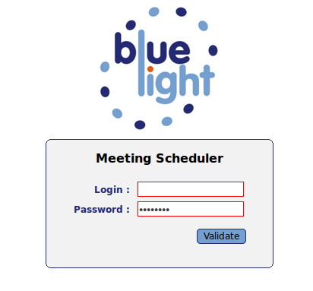
Type your login, password and validate. A menu appears.

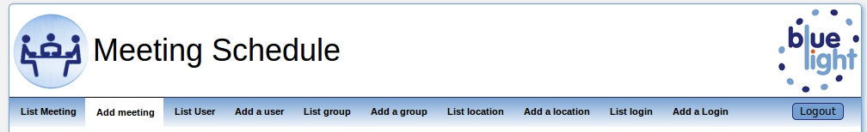

Create a new meeting
Click on 'Add meeting' menu. It appears a window.
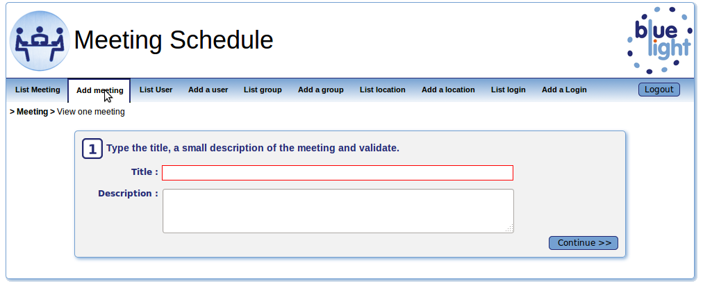
Type the title, description and click on 'Continue >>' button.

The calendar box appears.  Click on the day of the meeting you want to organize.  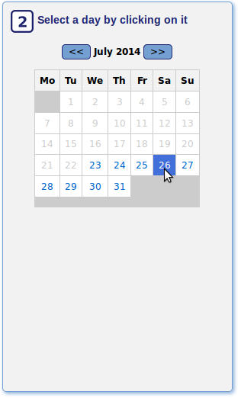 | The meeting schedule box appears.  Choose starting time, duration and location (select or add location if it does not exist).  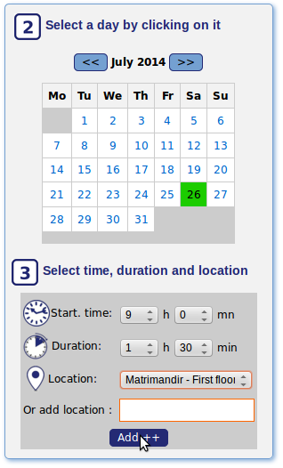  Click on Add button.
The first schedule meeting appears with day, time, duration and location.
You can add a second, third, etc by clicking on a day and fill the meeting schedule box.
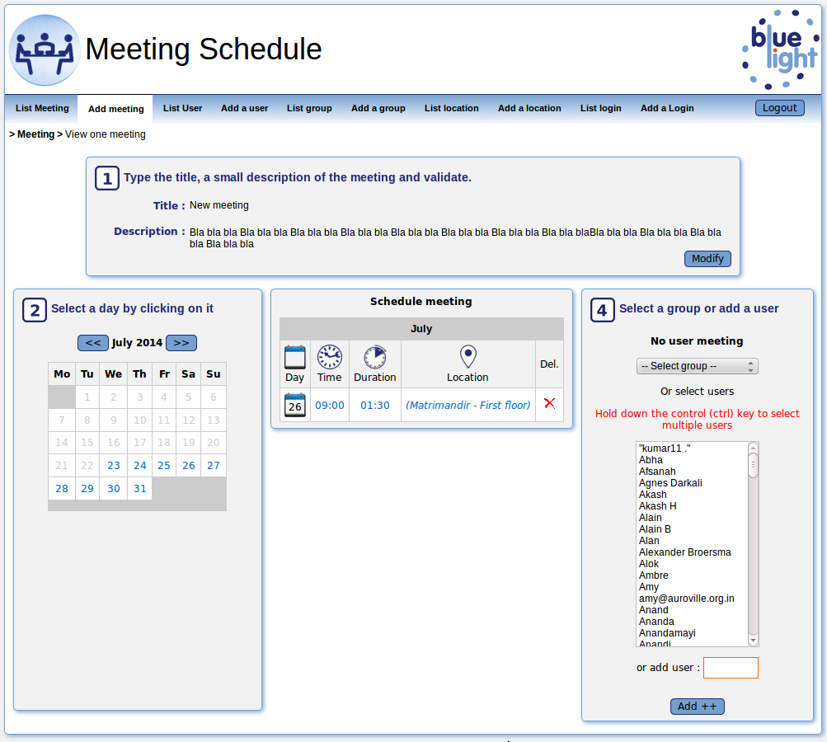
When you finished to define all your schedule meeting, you select the guests of the meeting. You also can select a group of guests and you click on 'Add' button.

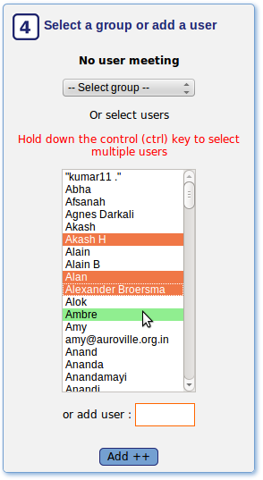

A link appears in a orange box on top. You can copy this link and send it by mail to the guests or click on the envelope image to open your mail box with a pre formatted text.

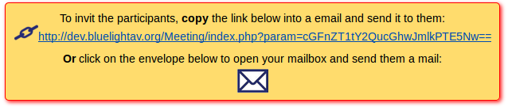
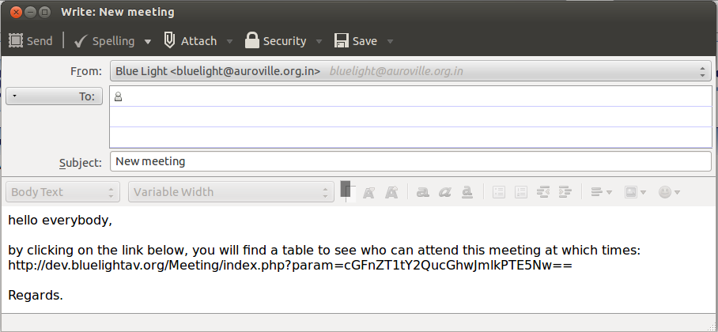

If you click on the link or you paste the link in your browser, a table appears with the guests and the date of the proposal meeting.

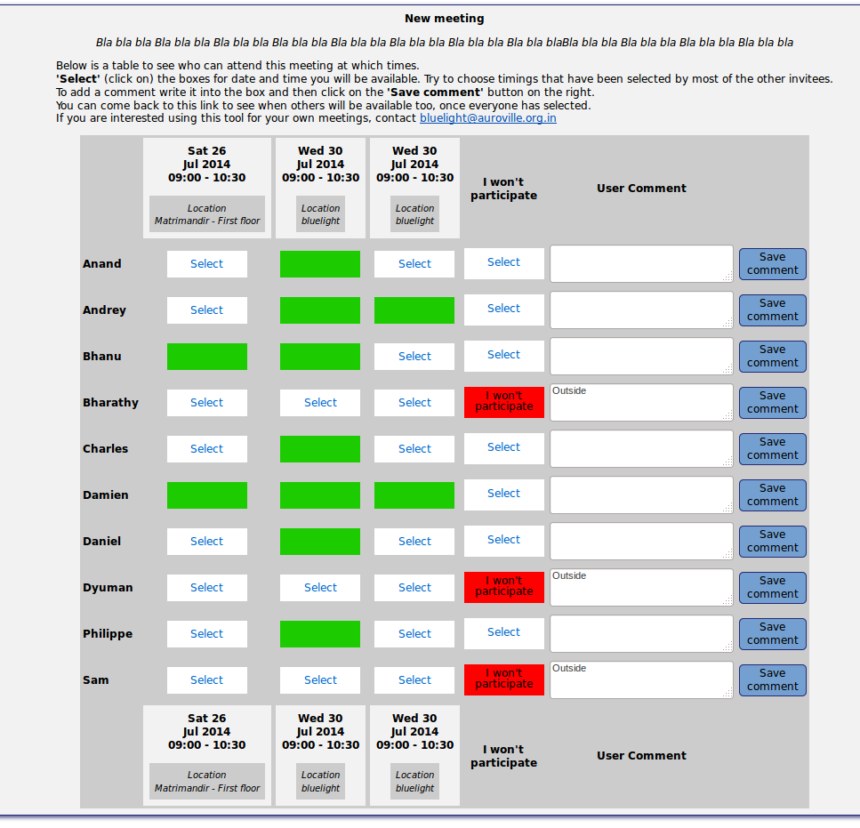

Add a group
In the menu you see List Group and Add a Group .
You don't have to create or use a group if you schedule only one or two meetings. But if you intend to schedule regular with and invite certain people a group is handy. Check out if the group you want to invite already exists or create a new group.
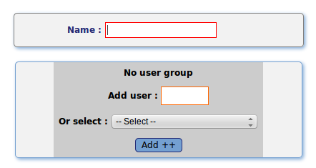
Enter a name of a new group and the add members to it. This tool is used but other people (in AV only). You can't add a user if this name is already present in the list under Select. Press the Add ++ button to confirm every entry.
Once you have created your group go back to the main menu click on Add a meeting.

Add a login
Only for Administrator.
By clicking on 'Add a login' menu, you can add a new login to give the access to the meeting scheduler.

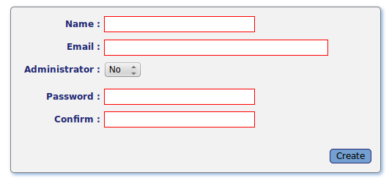
Type name and email.
Leave Administrator select menu on NO, otherwise the new login could add, modify, delete login.
Add and confirm password.
Send by mail the login and password to the new user of the application.

Hi Charles,
This is your access as administrator at the Meeting Scheduler:
http://dev.bluelightav.org/Meeting/backoffice/
username: charles
pwd: .......
Regards
Damien

Forgot a password
Only for Administrator.
If a user forgot his password, he can send a mail to Blue Light from the link 'Forget password ?' on the back office homepage.

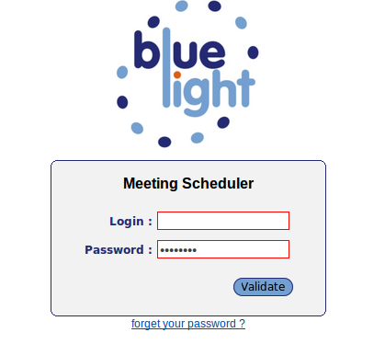

He send a mail to bluelight@auroville.org.in with subject Meeting Schedule: forget password and content:
I would like to renew my password for this username:
My email id:

As administrator, you enter into the meeting scheduler and click on 'List login'.
You find the user name and click on it to edit it.

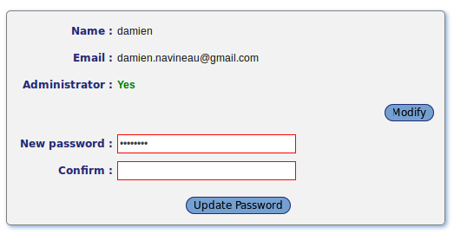

You click on 'New password' button, enter new password, confirm and save the new password by clicking on 'Update password'
Then, you send the new password to the user name trough the email id.

